Technical Specification

WRICEF ID.: | ALV Report
Project Name: | Support Project
Client Name: | Everenviro
WRICEF Description: | ALV Inreactive Report for display sales order data

TECHNICAL SPECIFICATION

Section 1: General Information
Project: | Support Project | Functional Area: | SD
VSD Functional Consultant | Harish Giri and Rohit Mahaveer | VSD Developer | Shivani Jha
Object Name: | ZSO_DETAIL_REPORT
Object Id | Report
Description | Report for display Sales Order data
Development Class |  |  |  | Package
Package | ZSD
File Name & Location in Solution Manager for FSD
File Name & Location in Solution Manager for TSD
Menu Path: (if applicable)
Mode | Foreground Background
Frequency | Monthly Weekly Daily Adhoc Others
Title:
Application Key: | NA
Complexity: | High Medium Low

Table of Contents
1 Scope Summary 5
1.1 Development Objects per System 5
2 Business Details 6
2.1 Summary / Business Background 6
2.2 Assumptions 6
3 Development Scope 7
3.1.1 Detailed Process Description 7
3.1.2 Data Model 7
3.2 Web Service - NA 7
3.2.1 Configuration 7
3.2.2 Development Objects 7
3.2.3 Business Logic 7
3.2.4 Error Handling 7
3.3 Workflow Development - NA 8
3.3.1 Configuration 8
3.3.2 Business Object creation / extension 8
3.3.3 Triggering Mechanism 8
3.3.4 Creation/Change of Workflow 8
3.3.5 Workflow Business Logic 8
3.3.6 Error Handling 8
3.4 Reports 8
3.4.1 Selection Screen 8
3.4.2 Business Logic 8
3.4.3 Output Format 8
3.4.4 Run Mode 8
3.4.5 Error Handling 8
3.5 Forms - NA 9
3.5.1 Layout Details / Sample Formats 9
3.5.2 Business Logic for Data Retrieval 9
3.5.3 Triggering Mechanism 9
3.5.4 Special Considerations 9
3.5.5 Error Handling 9
3.6 Dialog program / Web Developments (PCUI - BSP / WebDynpro) - NA 9
3.6.1 General 9
3.6.2 Screen Sequence 9
3.6.3 Business Logic 9
3.6.4 Bespoke Tables Updated 9
3.6.5 Error Handling 9
3.6.6 Multi-User Access Consideration 9
3.6.7 Branding Requirements 9
3.6.8 Screen layout 9
3.6.9 Field Definition 9
3.6.10 Menu implementation 9
3.6.11 Database update processing 10
3.7 Enhancements - 10
3.7.1 List of Enhancements 10
3.7.2 Business Logic 10
3.8 SAP PI – ABAP Proxy Development - NA 10
3.9 Class / Interface Development - NA 10
3.10 IDOC Development - NA 11
3.10.1 General 11
3.10.2 IDoc Customizing 11
3.10.3 Record Layout 11
3.10.4 Extension 11
3.10.5 IDoc Type 11
3.10.6 Message Type 11
3.10.7 Logical System 12
3.10.8 Process Code 12
3.10.9 Distribution Model 12
3.10.10 Transactional RFC Port 12
3.10.11 File Port 12
3.10.12 XML File port 12
3.10.13 XML HTTP 12
3.10.14 Partner profile 13
3.10.15 Inbound/outbound Parameters 13
3.10.16 Message Control 13
3.10.17 IDoc Processing 13
3.10.18 ABAP Processing 13
3.10.19 Description of Output 13
3.10.20 Programs/function modules for creation of IDOCs 14
3.10.21 Error handling for inbound/outbound (link to any workflow developments) 14
3.10.22 FTP scripting requirements 14
3.11 Function Module / RFC / BAPI - NA 14
3.12 Data Dictionary Objects - NA 16
3.12.1 Bespoke Table 16
3.12.2 Search helps 17
3.12.3 Lock Objects 17
3.13 Actions - NA 17
4 Authorizations 18
5 Message Class and Messages 19
6 Archiving – NA 20
7 Unit Test 21
7.1 Unit Test Specification 21
7.2 Test Data or Sample file 21
8 Version Control 22
9 Glossary - NA 23

1. Business Details

Summary / Business Background

Title | ALV Interactive Report
Description | ALV interactive report for display Sales Order data
Business purpose | ALV interactive report for display Sales Order data
Application area | SD
Tcode | ZSD_FOM

Reports

Selection Screen

S.No | Screen Label | Reference  Field | S or P | Default  Value | Mandatory  Yes / No | Comments
1 | Sales Organization | VBAK-VKORG | S | - | NO
2 | Sales Doccument No. | VBAK-VBELN | S | - | NO
3 | Customer No. | VBAK-KUNNRS | S | - | NO
4 | Document Date | VBAK-ERDAT | S | - | YES
5 | Material | VBAP-MATNR | S | - | NO
6 | Document Type | ZFOM | P | X | YES | Check Box
 |  | ZLFO | P | X | YES | Check Box

Business Logic
SELECTION SCREEN
As per the selection screen fields data should be display in ALV report, in above fields document date is
mandotory and document type is check box which are by default checked according to check box selection
data display.
LIST REPORT LOGIC
There are 27 fields in Report and below is the attached excel for logic and fields.



Output Format
Below is the screen shot of the report for referance. It is interactive report when click sales document no.,
billing document no.,delivery document no. va03,vf03,vl03n respectively transaction is open.

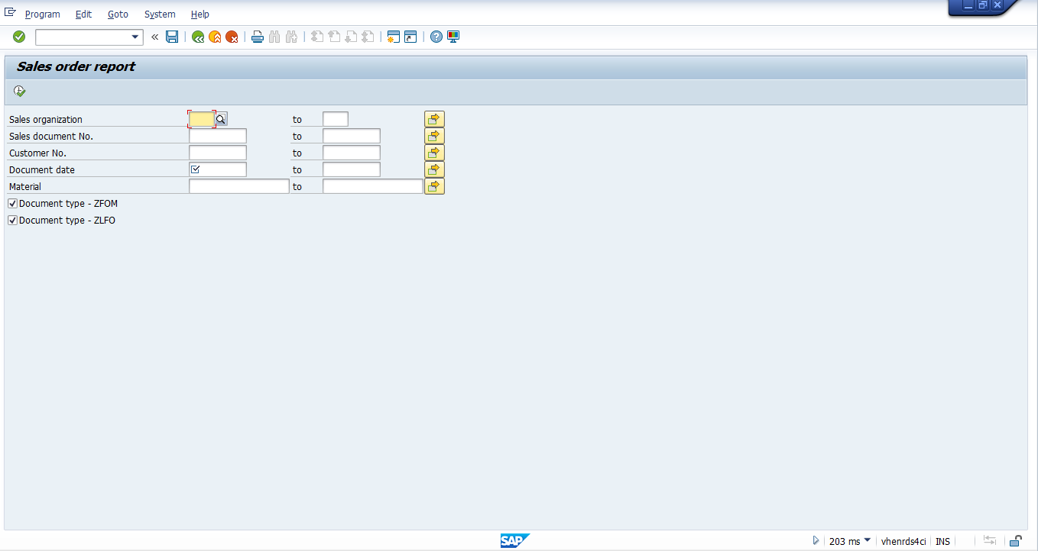
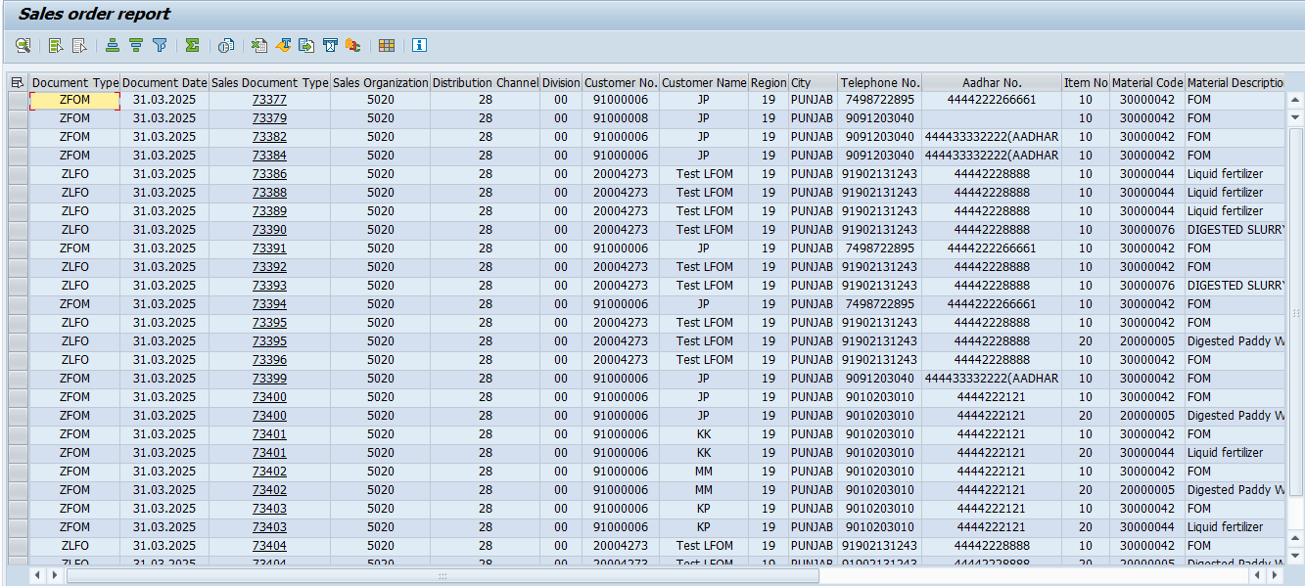

Unit Test

Unit Test Specification

According to the selection screen fields input data will display in ALV report.

Test Data or Sample file

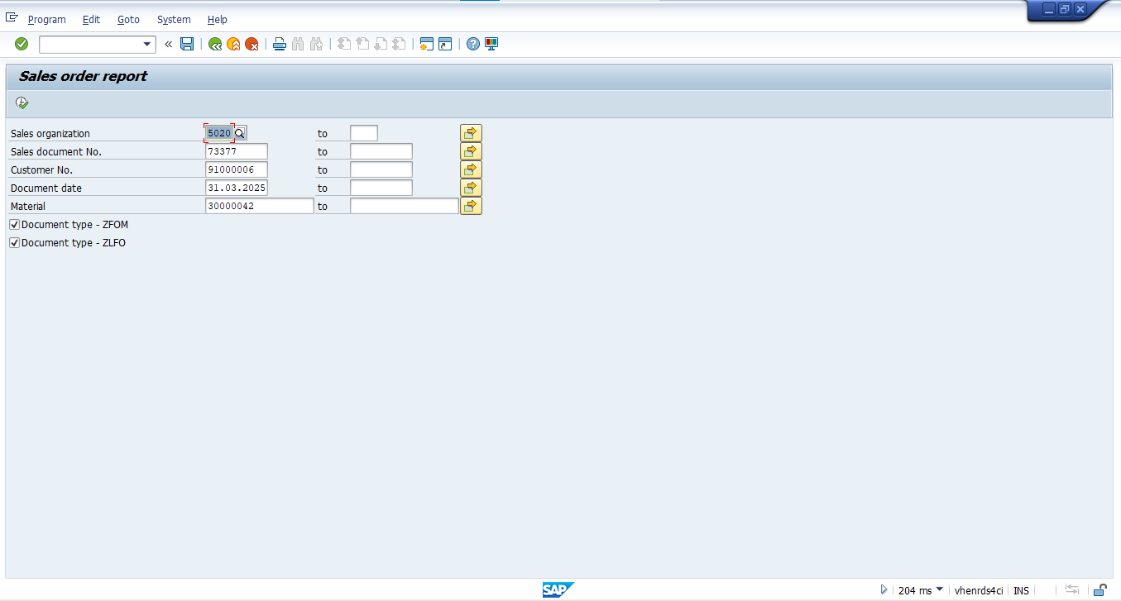

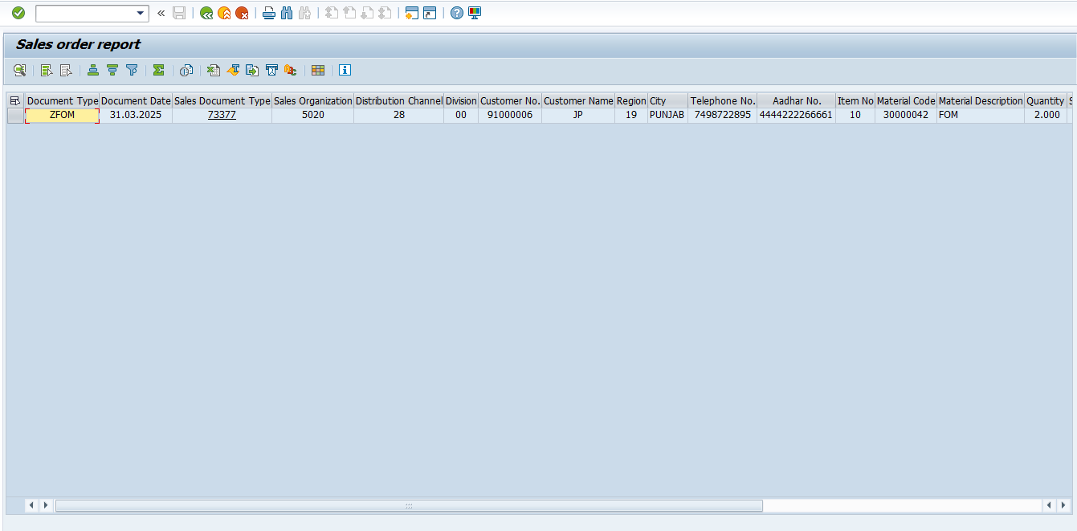

Version Control
Version | Date | Comment/Changes | Completed By | Transport
807 | 10.03.2025 | VSD: driver pgm - one time customer (SO) on 10.03.25 | Shivani Jha | DS4K903606

